**Critical steps in manufacturing the European Vacuum Vessel sectors reached**

[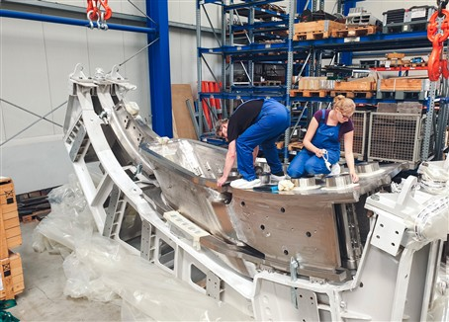](https://f4e.europa.eu/Downloads/News/08_VV_2_web-020920191200-Large.jpg)

Before welding: Inspection at ProBeam of the last sector 5 assembly with a central port arriving from Walter Tosto.

Critical steps in the continuing manufacturing the five European Vacuum Vessel sectors have been reached – three major tasks have been completed successfully – and the work in completing F4E’s contribution to ITER Vacuum Vessel continues with vigour.

The first accomplished task concerns the remaining nine Port Sub-Assemblies: MAN has completed and delivered six of these assemblies to Bellelli and the three others to Walter Tosto. Three central port subassemblies will be delivered in the next few months. The ITER Vacuum Vessel will have 44 openings, or ports, on three levels (lower, equatorial and upper). These ports will be connected to the port stub extensions. Port stub extensions can be seen as “windows” within the Vacuum Vessel which will allow access from the outside to the inside of the Vacuum Vessel. For example, the equatorial/middle port stub extension will provide access for the Neutral Beam to be injected in the plasma during ITER operation. The upper and lower port stub extensions will be useful during ITER installation and maintenance as these “windows” will facilitate access for Remote Handling equipment. In addition, the upper and lower port stub extensions will provide space for Diagnostic equipment for measuring and control during ITER operation.

“Our next challenge will be to ensure that the port-sub assemblies are welded to form each segment”, says Maja Bednarek, F4E’s Site Manager at MAN and Belleli.

The ITER Vacuum Vessel will have 44 openings, or ports, on three levels which create a link between the Vacuum Vessel and the tokamak cryostat and which are used for equipment installation, utility feedthrough, vacuum pumping, and maintenance.

The second realised task concerns Vacuum Vessel sector 5: the electron beam welding of all assemblies for this sector has been completed by ProBeam. As the first of five Vacuum Vessel sectors F4E is to deliver to ITER, sector 5 serves as the first example and the welding has been challenging work: electron beam welding on sector 5 has been carried out on a total of 398 joints – an impressive combined weld length of 520 metres. Electron beam welding is a welding process where a beam of high-velocity electrons is aimed at a narrow gap between two materials to be joined. The material used for the Vacuum Vessel, stainless steel grade 316L(N)-IG, melts and flows together as the kinetic energy of the electrons is transformed into heat upon impact. To ensure stability and precision of the process it is necessary to perform electron beam welding in vacuum chambers in order to prevent any interference to the electron beam. With the large Vacuum Vessel assemblies weighing over 10 tonnes and spanning over 6 metres it is very challenging to maintain tolerances when mounting all joints. “The main benefit with electron beam welding is that it reduces distortions due to rapid joining with one beam pass compared to conventional TIG welding where the layer by layer approach keeps the joint close to melting temperature for a longer time” says Stefan Wikman, Material Expert and F4E Site Manager for ProBeam. When preparing the assembling of the different parts of the sector assemblies, rigorous planning is required in order to ensure the correct positioning that will keep the tight global flatness tolerances and at the same time ensure that the gaps for electron beam welding are within limits (in some cases between 0.6 – 0.8 mm) and clean of impurities. “It’s been a steep learning curve which has involved a great team effort by all parties in order to overcome the technical challenges whilst adhering to the strict nuclear code requirements. Everyone involved should feel proud of this achievement. ProBeam has also completed the welding of 162 joints on 11 assemblies during a 30-day period. This marks the peak load of electron beam welding, and includes four large segment 1 assemblies for Vacuum Vessel sectors 4, 3, 2 and 9,” says Stefan Wikman.

Thirdly, Walter Tosto has started installation of the Vacuum Vessel’s In-wall Shielding Block on the Poloidal Segment 3 on Sector 5. Manufactured by the Indian Domestic Agency, a total of 47 blocks will be used in the installation. The blocks are made of stainless steel with high boron content as boron absorbs fast neutrons emitted by the plasma during fusion reactions. Installation is a critical task as it means that a large portion of the Vacuum Vessel segment becomes blocked off and any analysis or testing must be completed before the blocks can be mounted. “The start of in-wall shielding block installation is the point of huge significance for the Vacuum Vessel as once the installation has started it is impossible to make any further modifications”, says Max Febvre, who is in charge of the Vacuum Vessel Manufacturing. “Installation also means that the complete, extensive documentation is in accordance with safety regulations, needs to completed and fully approved” says John-paul McCrone, who is in charge of the Vacuum Vessel End of Manufacturing Report for all European sectors.